Name: Christian Alvarez
Date: November 23, 2025
Class: IT2249
Unit: U7A1 Count Occurrences in Seven Integers Using Java
Single Dimension Arrays

Source Code
1. package u7a1_numofoccurrinsevenint;
2.
3. import java.util.Scanner;
4.
5. /**
6. * @author christian
7. *
8. * This program will check the import of seven integers from the user.
9. * It will then count the number of times each number occurs.
10. * Output the number of occurrences of each number to the console
11. *
12. * pseudocode:
13. * 1. declare an array to store user inputs
14. * 2. get 7 numbers from the user
15. * 3. process the input array to count how many times each unique number appears
16. * 4. check for and store each individual number and its occurrences (i.e., 3 occurs 7 times)
17. * 5. display the occurrences of each individual number to the console
18. *
19. */
20.
21. public class U7A1_NumOfOccurrInSevenInt {
22. // declare an array to store user inputs
23. public static int MAXNUBERS = 7;
24. public static int[] USERNUMBERS = new int[MAXNUBERS];
25.
26. // count occurences of a number
27. public static int occurenceOfNumber(int[] numbers, int numberToCheck) {
28. int count = 0;
29. for (int i = 0; i < numbers.length; i++) {
30. if (numbers[i] == numberToCheck) {
31. count++;
32. }
33. }
34. return count;
35. }
36.
37. // parse array and format output
38. public static String parser(int[] numbers) {
39. String result = "";
40.
41. // declare an array to store checked numbers
42. boolean[] checked = new boolean[MAXNUBERS];
43.
44. // loop through user numbers
45. for(int i = 0; i < numbers.length; i++) {
46. // skip if number was counted already
47. if (checked[i]) {
48. continue;
49. }
50.
51. // get current number
52. int currentNumber = numbers[i];
53.
54. // get occurences of current number
55. int count = occurenceOfNumber(numbers, currentNumber);
56.
57. // add to result
58. result += String.format("%d occurs %d times%n", currentNumber, count);
59.
60. // mark checked numbers
61. for(int j = i; j < numbers.length; j++) {
62. if(numbers[i] == numbers[j] && i != j) {
63. checked[j] = true;
64. }
65. }
66. }
67.
68. // return result
69. return result;
70. }
71.
72. public static void main(String[] args) {
73.
74. // create scanner object
75. Scanner scn = new Scanner(System.in);
76.
77. // prompt user for input
78. System.out.print("Enter 7 integers: ");
79. // use for loop to get user input
80. for(int i = 0; i < MAXNUBERS; i++) {
81. USERNUMBERS[i] = scn.nextInt();
82. }
83.
84. // output result to console
85. System.out.print(parser(USERNUMBERS));
86.
87. // close scanner object
88. scn.close();
89.
90. }
91.
92. }
Screenshots
Failing Test

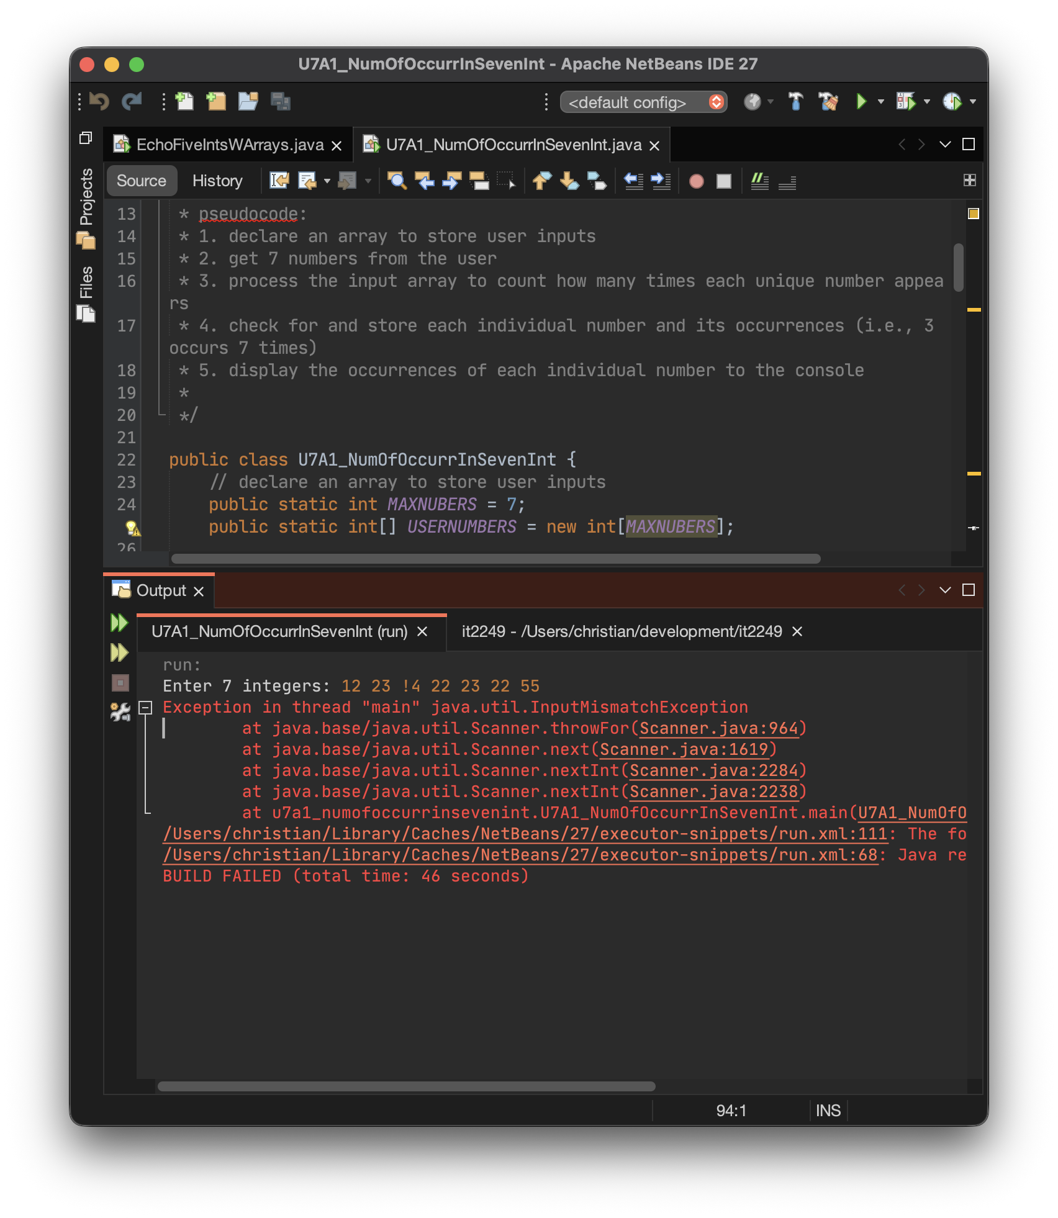
Passing Test

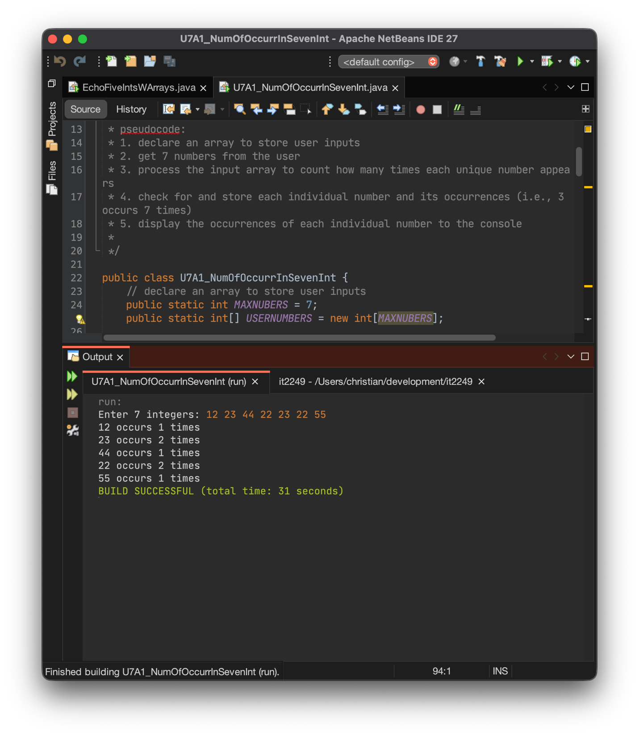
Explanation
This assignment required developing a Java console application that reads seven integers from user input and counts how many times each unique number appears in the collection. The program needed to use single-dimension arrays to store and process the data, then display the occurrence count for each distinct value entered by the user.
I found this assignment to be a bit more challenging than previous weeks, primarily due to the way Java implements arrays and the logic required to avoid counting duplicate numbers multiple times. The core difficulty was ensuring that each unique number was only reported once, even if it appeared several times in the input. To solve this, I implemented a boolean array that tracks which positions in the original array have already been processed. This tracking mechanism prevents the program from reporting the same number's occurrence count more than once.
The approach I took involved breaking the problem down into three main components. First, I created a method called occurenceOfNumber that accepts the array of user inputs and a specific number to check, then returns how many times that number appears in the array. This method uses a simple loop with a counter that increments each time it finds a match. Second, I developed a parser method that iterates through the entire array while maintaining the boolean tracking array. For each position that hasn't been checked yet, the parser retrieves the current number, calls occurenceOfNumber to get its count, formats the output string, and then marks all other positions containing that same number as checked. This prevents redundant counting and reporting. Third, the main method handles user input collection using a Scanner object and a for loop to populate the array with exactly seven integers.
Several fundamental Java constructs were essential to implementing this solution. The single-dimension array construct was used twice in the program, once to store the seven user-entered integers and again to maintain the boolean flags tracking which array positions had been processed. The for loop construct appeared in multiple places, including the user input collection phase and within both the occurenceOfNumber and parser methods for iterating through array elements. Conditional logic using if statements was crucial for checking whether a number matched the target value and for determining whether an array position had already been processed. The String.format method provided a clean way to create the output strings with proper formatting, ensuring the results displayed correctly to the user.
Testing the application with the provided input values of 12, 23, 44, 22, 23, 22, and 55 confirmed that the program correctly identified and counted each unique number. The output showed that 12 occurred once, 23 appeared twice, 44 appeared once, 22 occurred twice, and 55 appeared once, which matched the expected results exactly. The boolean tracking array successfully prevented any duplicate reporting, and the formatting ensured the output was clear and easy to read.
This project reinforced several important programming concepts, particularly the importance of using helper methods to break complex problems into manageable pieces. The occurenceOfNumber method could be tested and verified independently, which made debugging much simpler. The experience also highlighted how tracking arrays or flags can be valuable when you need to mark certain data as processed without modifying the original data structure. Working through the logic of avoiding duplicate counts really strengthened my understanding of array manipulation and iteration patterns in Java. While the array implementation in Java initially presented some challenges, especially around understanding how to properly track processed elements, the final solution turned out to be relatively elegant and efficient.

